WitleShop Online Retail System
Entity Relationship Diagram (ERD) Assignment
Introduction
WitleShop (Pty) Ltd is a South African online retail company that sells electronics, clothing and home appliances through a web and mobile platform. The company requires a database system to manage customers, products, orders, payments, deliveries and suppliers.
The purpose of this assignment is to identify the entities required for the WitleShop database, identify the primary and foreign keys, establish the relationships between entities, determine the cardinality of each relationship, and design a complete Entity Relationship Diagram (ERD).

1. Identify All Entities
Based on the business requirements, the following entities are required:
- Customer
- Address
- Product
- Category
- Supplier
- Order
- OrderItem
- Payment
- Delivery
Explanation of the entities
Entity | Description
Customer | Stores information about customers who register with WitleShop.
Address | Stores the delivery addresses registered by customers.
Product | Stores information about products sold by WitleShop.
Category | Stores product categories.
Supplier | Stores information about suppliers providing products.
Order | Stores information about orders placed by customers.
OrderItem | Links products to orders and resolves the M:N relationship.
Payment | Stores payment information for an order.
Delivery | Stores delivery information for an order and its delivery address.

2. Identify Primary Keys
A primary key (PK) is an attribute that uniquely identifies each record in an entity.
Entity | Primary Key | Description
Customer | CustomerID | Uniquely identifies each customer.
Address | AddressID | Uniquely identifies each address.
Product | ProductID | Uniquely identifies each product.
Category | CategoryID | Uniquely identifies each category.
Supplier | SupplierID | Uniquely identifies each supplier.
Order | OrderID | Uniquely identifies each order.
OrderItem | OrderItemID | Uniquely identifies each item within an order.
Payment | PaymentID | Uniquely identifies each payment.
Delivery | DeliveryID | Uniquely identifies each delivery.

3. Entity Attributes and Primary Keys
3.1 Customer
The Customer entity stores information about customers who register before placing orders.
CUSTOMER
Attribute | Description | Key
CustomerID | Unique customer identifier | PK
FullName | Customer's full name | —
Email | Customer's email address | Unique
PhoneNumber | Customer's phone number | —
RegistrationDate | Date the customer registered | —

3.2 Address
A customer can have multiple delivery addresses. Therefore, Address must be a separate entity.
ADDRESS
Attribute | Description | Key
AddressID | Unique address identifier | PK
CustomerID | Identifies the customer who owns the address | FK
DeliveryAddress | Customer's registered delivery address | —
Relationship: Customer → Address = 1:M

3.3 Product
The Product entity stores the products sold by WitleShop.
PRODUCT
Attribute | Description | Key
ProductID | Unique product identifier | PK
ProductName | Name of the product | —
Description | Description of the product | —
Price | Price of the product | —
StockQuantity | Quantity currently in stock | —
CategoryID | Identifies the product category | FK
SupplierID | Identifies the product supplier | FK

3.4 Category
The Category entity stores the categories to which products belong.
CATEGORY
Attribute | Description | Key
CategoryID | Unique category identifier | PK
CategoryName | Name of the category | —
Examples of categories include:
- Electronics
- Clothing
- Home Appliances

3.5 Supplier
The Supplier entity stores suppliers that provide products to WitleShop.
SUPPLIER
Attribute | Description | Key
SupplierID | Unique supplier identifier | PK
SupplierName | Name of the supplier | —
The case study only specifies that each product has a supplier. Therefore, SupplierName is sufficient for the ERD.

3.6 Order
The Order entity stores information about orders placed by customers.
ORDER
Attribute | Description | Key
OrderID | Unique order identifier | PK
CustomerID | Customer who placed the order | FK
OrderDate | Date the order was placed | —
OrderStatus | Current status of the order | —
TotalAmount | Total amount of the order | —
The allowed order statuses are:
- Pending
- Shipped
- Delivered
- Cancelled

3.7 OrderItem
The case study states:
An order can contain multiple products.
and:
A product can appear in multiple orders.
This creates a many-to-many (M:N) relationship between Order and Product.
A separate entity called OrderItem is therefore required to resolve the M:N relationship.
ORDER_ITEM
Attribute | Description | Key
OrderItemID | Unique order item identifier | PK
OrderID | Identifies the order | FK
ProductID | Identifies the product | FK
The OrderItem entity allows the database to record which products belong to each order.

3.8 Payment
The Payment entity stores payment information for each order.
PAYMENT
Attribute | Description | Key
PaymentID | Unique payment identifier | PK
OrderID | Identifies the order being paid for | FK
PaymentDate | Date payment was made | —
PaymentMethod | Method used for payment | —
PaymentStatus | Status of the payment | —
AmountPaid | Amount paid | —
Payment methods are:
- Card
- EFT
- PayFast

3.9 Delivery
The Delivery entity stores information about the delivery of an order.
DELIVERY
Attribute | Description | Key
DeliveryID | Unique delivery identifier | PK
OrderID | Identifies the order being delivered | FK
AddressID | Identifies the customer's registered delivery address | FK
DeliveryDate | Date of delivery | —
DeliveryStatus | Current delivery status | —
CourierName | Name of the courier | —
TrackingNumber | Delivery tracking number | —
The AddressID foreign key ensures that the delivery is linked to one of the customer's registered addresses.

4. Identify Foreign Keys
A foreign key (FK) is an attribute that links one entity to another entity's primary key.
Entity | Foreign Key | References
Address | CustomerID | Customer(CustomerID)
Product | CategoryID | Category(CategoryID)
Product | SupplierID | Supplier(SupplierID)
Order | CustomerID | Customer(CustomerID)
OrderItem | OrderID | Order(OrderID)
OrderItem | ProductID | Product(ProductID)
Payment | OrderID | Order(OrderID)
Delivery | OrderID | Order(OrderID)
Delivery | AddressID | Address(AddressID)

5. Identify Relationships
The following relationships exist in the WitleShop database.
Relationship 1: Customer – Address
A customer can have multiple delivery addresses.
Cardinality: 1:M
Customer 1 ───────── M Address
One customer can have many addresses, but each address belongs to one customer.

Relationship 2: Customer – Order
A customer can place multiple orders.
Cardinality: 1:M
Customer 1 ───────── M Order
One customer can place many orders, but each order belongs to one customer.

Relationship 3: Category – Product
Each product belongs to one category, while a category can contain many products.
Cardinality: 1:M
Category 1 ───────── M Product

Relationship 4: Supplier – Product
Each product is supplied by one supplier, while a supplier can supply many products.
Cardinality: 1:M
Supplier 1 ───────── M Product

Relationship 5: Order – Product
An order can contain multiple products, and a product can appear in multiple orders.
Cardinality: M:N
Order M ───────── N Product
A direct M:N relationship is not normally implemented directly in a relational database. Therefore, the OrderItem entity is used.
The relationship becomes:
Order 1 ───────── M OrderItem M ───────── 1 Product

Relationship 6: Order – Payment
Each order has one payment record, and each payment belongs to one order.
Cardinality: 1:1
Order 1 ───────── 1 Payment

Relationship 7: Order – Delivery
Each order has one delivery record, and each delivery belongs to one order.
Cardinality: 1:1
Order 1 ───────── 1 Delivery

Relationship 8: Address – Delivery
A delivery must be linked to one of the customer's registered addresses.
Cardinality: 1:M
Address 1 ───────── M Delivery
One registered address may be used for deliveries for multiple orders, while each delivery uses one address.

6. Cardinality Summary
Relationship | Cardinality | Explanation
Customer → Address | 1:M | One customer can have multiple addresses.
Customer → Order | 1:M | One customer can place multiple orders.
Category → Product | 1:M | One category can contain many products.
Supplier → Product | 1:M | One supplier can supply many products.
Order → OrderItem | 1:M | One order can contain multiple order items.
Product → OrderItem | 1:M | One product can appear in multiple order items.
Order → Product | M:N | Orders can contain many products and products can appear in many orders.
Order → Payment | 1:1 | Each order has one payment.
Order → Delivery | 1:1 | Each order has one delivery.
Address → Delivery | 1:M | An address can be used for multiple deliveries.

7. Complete ERD
The following is the complete logical structure of the WitleShop ERD.

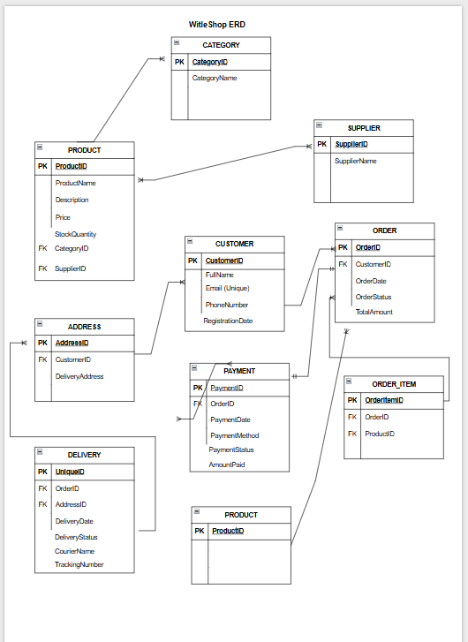
8. Final Entity List
The completed WitleShop database therefore contains:
Entity | PK | Main FKs
Customer | CustomerID | —
Address | AddressID | CustomerID
Category | CategoryID | —
Supplier | SupplierID | —
Product | ProductID | CategoryID, SupplierID
Order | OrderID | CustomerID
OrderItem | OrderItemID | OrderID, ProductID
Payment | PaymentID | OrderID
Delivery | DeliveryID | OrderID, AddressID
10.Conclusion
The WitleShop Online Retail System requires nine entities to represent the business requirements: Customer, Address, Product, Category, Supplier, Order, OrderItem, Payment and Delivery.
Primary keys are used to uniquely identify records within each entity, while foreign keys are used to establish relationships between entities.
The database contains several one-to-many (1:M) relationships, including Customer to Order, Customer to Address, Category to Product and Supplier to Product. It also contains two one-to-one (1:1) relationships, namely Order to Payment and Order to Delivery.
The relationship between Order and Product is a many-to-many (M:N) relationship because an order can contain multiple products and a product can appear in multiple orders. This relationship is resolved using the OrderItem entity.
The resulting ERD provides a complete database structure that satisfies the requirements given for the WitleShop Online Retail System.
:::

